Contents

1. Generate Client ID and Secret of Xray plugin 2
2. Configure XRAY with the JIRA Project 4
3. Migrate Test cases from Spira to Xray 6

Generate Client ID and Secret of Xray plugin

- Open JIRA application and select Settings
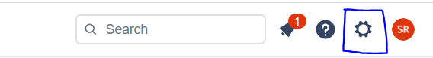
- Under Jira Settings select Apps
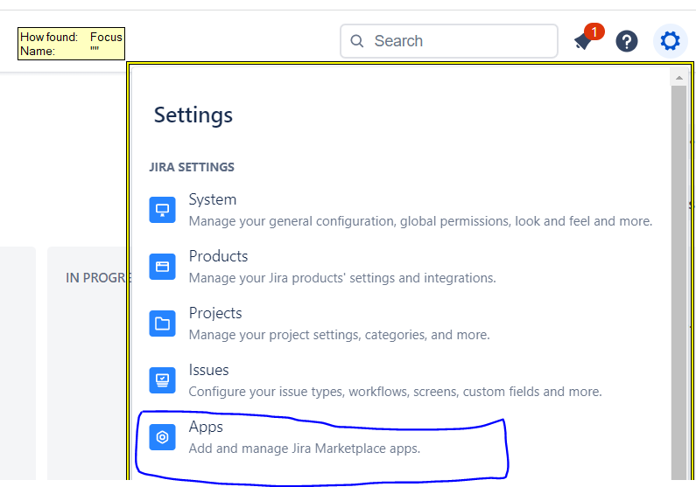
- This will open Marketplace Apps page and under Apps navigation section, select XRAY and then select API Keys
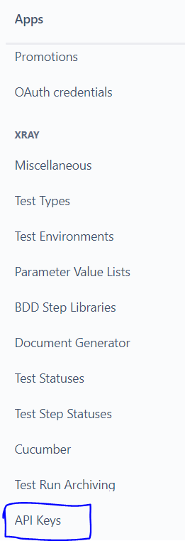
- On the API Keys page select the Create API Key button

- On the Create API Key page select and registered JIRA user name and select Generate
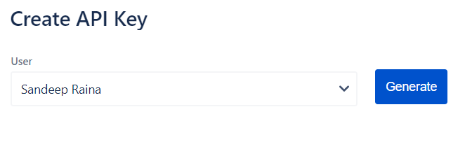
- API Key with Client ID and Secret will automatically get generated.
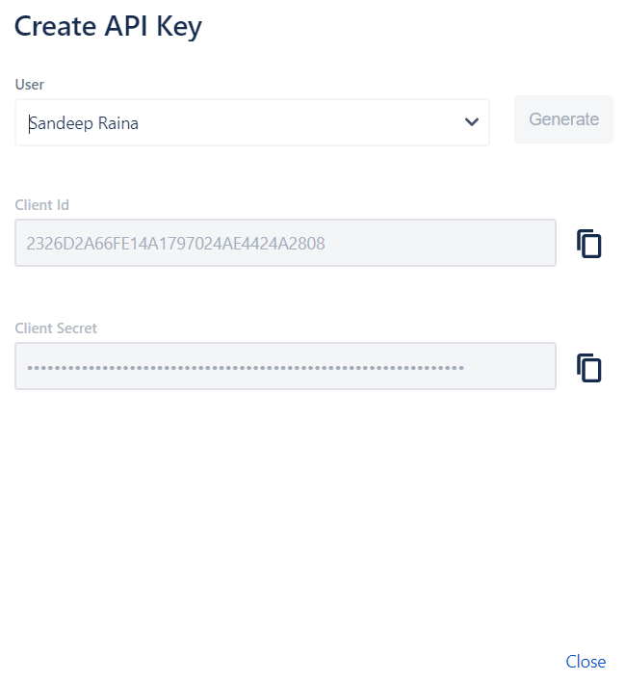

Configure XRAY with the JIRA Project

- Open a JIRA project and select Project Settings located on the left-hand side of the navigation bar.
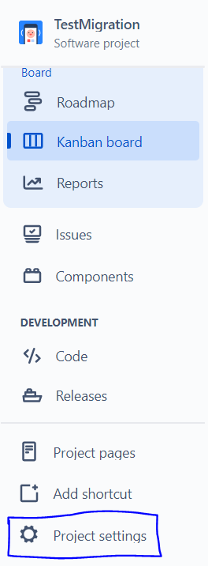
- On the Project Settings page, select Xray Settings under Apps located on the left-hand side of the navigation bar.
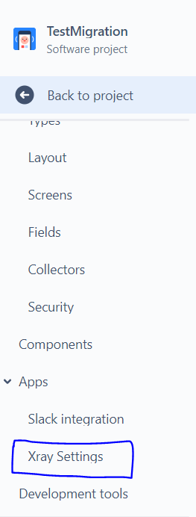
- Under Summary, Issue Types (Xray Issue Types in Project) will be visible. Map it by either selecting Add Xray Issue Types which will automatically map the issues with the selected JIRA project or by selecting Configure the Issue Type Scheme manually through which user can manually map the required issue types with the selected JIRA project.
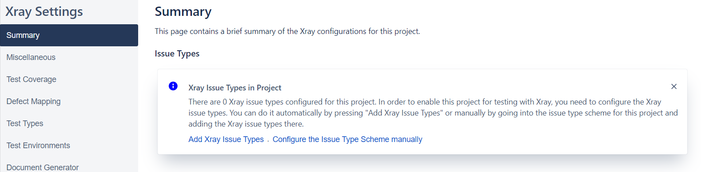
- Once the issue is linked Summary page will display the linked Xray Issue types available in the selected project.
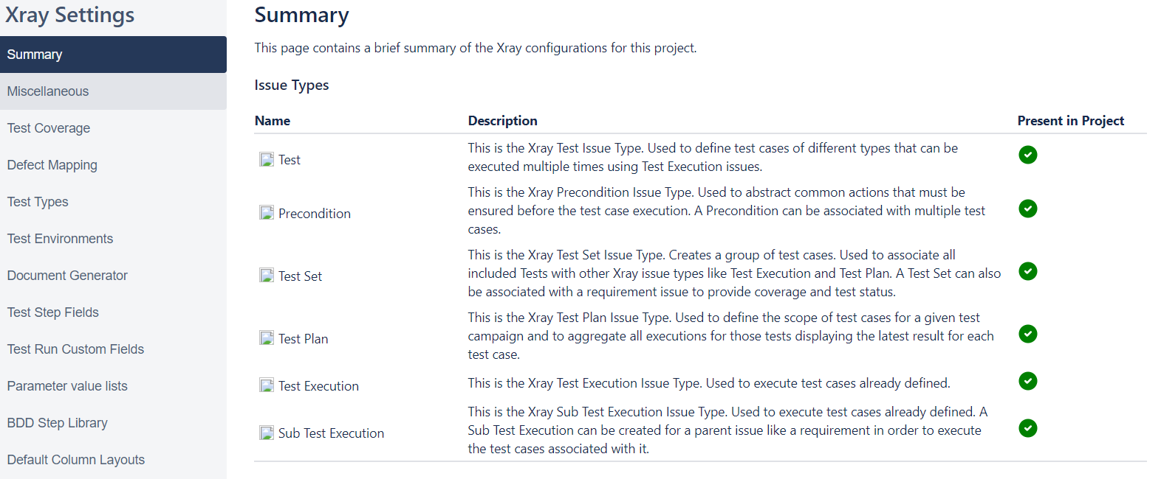
- Go back to your JIRA project and users will see Testing Board added on the left-hand side of the navigation bar. (Refresh the page once if the entry not visible)
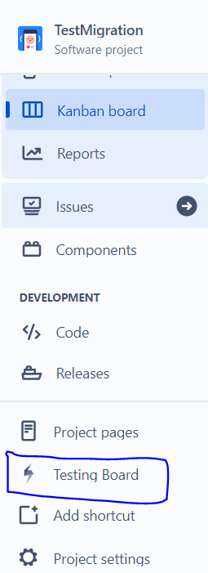

Migrate Test cases from Spira to Xray

- To migrate the test cases from Spira to Xray run an executable jar file with name SpiraToXray v1.0.jar
- SpiraToXray v1.0.jar takes four parameters which are listed below.
  - JIRA project key
  - Xray Client ID (refer the section Generate Client ID and Secret of Xray plugin)
  - Xray Client secret (refer the section Generate Client ID and Secret of Xray plugin)
  - Spira XML file name along with path
Please see: The JIRA project key can be seen in the following ways.
- The URL
- On the View all projects page
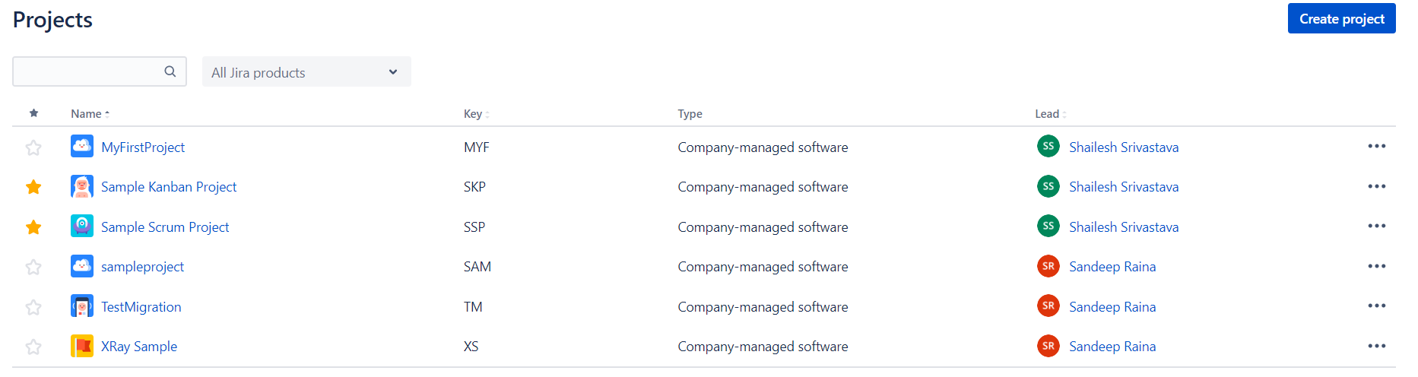
- Execute the SpiraToXray v1.0.jar in the command prompt by the following way.
java -jar "C:\Users\raina\Documents\GitHub\SpiraToXray\target\SpiraToXray v1.0.jar" <projectkey> <clientid> <clientsecret> <xmlfilepath>

e.g.:

java -jar "C:\Users\raina\Documents\GitHub\SpiraToXray\target\SpiraToXray v1.0.jar" "XS" "C623CC0A82C642F99A2AA0608996D11F" "8df38a13f12376a8565c60df789999efec5f49f954822841280ea576eb325167" "file:///C:/Users/raina/Desktop/Generated.xml"

